2021-22 Foundation for the History of Totalitarianism Essay Prize
The winning essay on
the Stasi
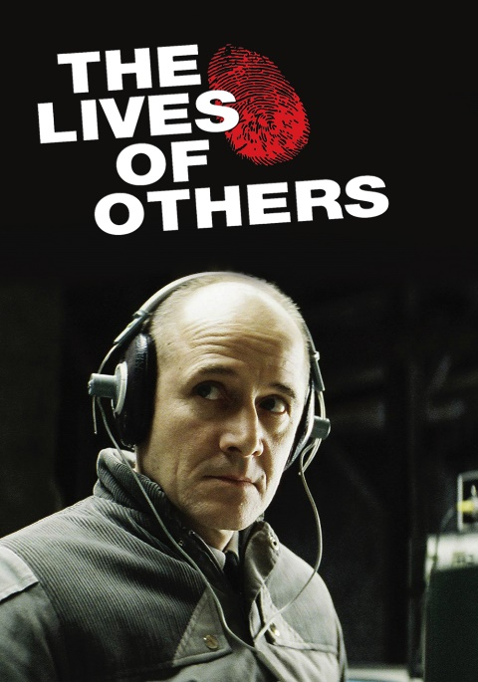
Still from the film about the
Stasi, The Lives of Others

Miriam Weber was just sixteen years old when she was made an Enemy of the State. Her heinous crime? Calling for people to speak out in the German Democratic Republic. Her story resonated with me not just because of the insight it offers into life under the Stasi, but because she was roughly my age when she was charged with sedition and treated as a traitor. The Stasi behaved like the villain in a dystopian novel: an omnipotent Orwellian organisation, operating as a state within a state to suppress freedoms and punish dissent. But for people like Miriam, the story of the Stasi was not the work of literature; it was a daily reality with which they were confronted.

Founded in 1950, the Stasi was modelled on the Cheka, the secret police from the early years of the Soviet Union. Much like in the USSR, the objective was to safeguard communist ideology and suppress resistance. Its role was not to protect East Germany itself but the interests of the ruling Socialist Unity Party – the S.E.D. By June 1953, living standards in East Germany were falling. Food prices and work quotas were rising, which caused resentment and anger amongst the population, culminating in an uprising against the SED. Although the rebellion was quelled, the Stasi had been blindsided, primarily because it wasn’t equipped for comprehensive internal surveillance, preferring instead to target notable opposition groups and individuals based in West Berlin. Therefore the SED quickly noted that threats from within needed to be monitored as carefully as threats from abroad, and the Stasi’s powers were expanded.

Within East Germany, the Stasi monitored every aspect of society and exercised immense power. The Stasi spied on dissidents and those accused of doubting communist ideology by wire-tapping phones, bugging apartments, or steaming open and resealing letters: it even set up eavesdropping stations along the border into West Germany and, in good weather, the Stasi could pick up calls from Frankfurt and Cologne. Until the 1970s, the Stasi even punished those who had television antennas angled towards the west, accusing them of consuming West German media. To carry out this function, the Stasi relied on a vast web of informants, unofficially employing nearly 170,000 people by 1989. The Stasi turned friends against each other and, in some cases, even families; Vera Lengsfeld divorced her husband in 1992 after discovering he had been a Stasi informant since the 1970s, filing reports on her activities until the collapse of the GDR. Even beyond the borders, East Germans were not free from the Stasi. It is estimated that, across its 40-year history, the Stasi captured 13 people who had fled to West Germany and returned them to the east, demonstrating that they were not afraid to cross international borders to protect the interests of the SED. The Stasi was more than willing to torture, both psychologically and physically, those it arrested. After Miriam Weber was released, awaiting trial for her charge of sedition, she tried to flee across the Berlin Wall as a political refugee but didn’t make it. She was arrested by the Stasi and questioned on who had supported her in her attempted escape. Miriam told them the truth: she had decided to flee and acted alone. For the next ten days, she was held in solitary confinement and denied any sleep. On the eleventh night, the exhaustion broke her and she made up lies to end the torture. It is clear that the Stasi had no moral compass, doing whatever it took to get information or even, in Miriam’s case, to get individuals to invent false narratives and name people they hadn’t even met.

By the 1970s, the Stasi had moved away from tactics such as arrest and torture, as these methods were beginning to attract unwanted international attention. They began to favour psychological means of harassing suspects. This campaign of psychological intimidation was designed to weaken the will of individuals or groups to force them into submission, essentially breaking down the opposition – hence it was given the name ‘Zersetzung’, meaning ‘decomposition’ in German.

For political parties or groups operating underground, the Stasi would aim to render them ineffective by creating conflict between members, sabotaging their activities by using informants on the inside and isolating groups from other organisations by spreading rumours and creating myths. The ultimate goal of Zersetzung in such cases was to cripple the group or party and undermine their activities to the point that they gave up. However, Zersetzung of individuals was the more common tactic experienced by East Germans. The Stasi would gather all state-held information on a person and look for weaknesses to exploit before alerting the individual they were being watched, either through repeated stop and searches or visiting them at home or work. The Stasi would then begin a campaign of psychological harassment, such as moving things around at home, damaging bikes and vehicles by slashing tyres, ringing the telephone in the middle of the night only to hang up immediately. Families were even used as leverage against activists as a method of blackmail. The ultimate aim was for the individual to lose morale and eventually give up their goals.

For ordinary East Germans, this was inescapable. The Stasi built a culture of paranoia, causing citizens constantly to check over their shoulders wherever they went and suspect the worst. People were afraid to express opinions, even in person as it could never be determined who was working with the Stasi. By 1989, one in 63 East Germans were collaborating with the Stasi, either as a direct employee or as an informant. The iron grip of the secret police was unavoidable. But it was only when Germany was reunified that people finally realised the extent to which the Stasi had infiltrated their lives. When Heidi Brauer accessed her Stasi file, she found 1,500 pages of content collected by “12 different spies”. They had tapped her telephones and intercepted her letters. Much like Miriam, her crime was something so insignificant and harmless: she had been listening to West German radio. For this, she was observed and treated like a dangerous criminal. But this was considered highly offensive by the Stasi, as it represented doubts about communist ideology. For people like Heidi, they just wanted to feel free.

The question must then be asked, what kind of government would create this secret police? What does it say about the SED that they allowed the Stasi to operate unchecked or unrestricted? The SED held a political monopoly in East Germany and earned itself a reputation as being one of the most hard-line communist parties in the Soviet bloc. But the SED never had a democratic mandate; they were never elected by the people. Therefore, communism was imposed rather than chosen to govern East Germany, and, in order to protect the interests of a party with no electoral backing, the SED needed an equally hard-line police state to lean on. This supports the idea that the SED never had the interests of the East German public at heart. They created a secret police apparatus to be the “shield and sword of the Party” rather than of the country – though undoubtedly members of the government would argue that country and party were the same.

Another question must also be asked when looking at the history of the Stasi: this was one of the most pervasive secret police organisations in history, so why did it not act during the 1989 Peaceful Revolution? It was more than willing to crush doubters and dissidents psychologically, so why did it not crush the outpouring of dissent in 1989? Firstly, it was becoming increasingly difficult to recruit informants by the late 1980s. This would naturally impact the Stasi's ability to monitor unrest amongst the population. Also, by this time, knowledge of the Stasi’s methods and activities was becoming more widespread and people knew how to keep low profiles and evade the Stasi, thus hindering their surveillance abilities even further. Furthermore, if the SED wanted to suppress the revolution, they now had to do it alone. When Mikhail Gorbachev became the General Secretary of the USSR in 1985, he refused to put an end to the Solidarity movement that was threatening the communist government in Poland. This effectively ended the Brezhnev Doctrine – a foreign policy initiative that proclaimed a threat against communism in one Soviet bloc country was a threat against them all and would be met with military force. This was of particular concern for SED leader Erich Honecker who had been ignoring the growing dissent across Eastern Europe in the hope that the USSR would intervene. It was acknowledged that repression would not be supported militarily by Moscow and the SED would have to deal with this on their own; so the Stasi could not be guaranteed a peaceful rebellion would be successfully quelled.

In 1992, Erich Mielke, the head of the Stasi, proclaimed “had the party given me orders, maybe East Germany would still exist today.” However, it could easily be argued that, by this stage, the SED and the Stasi had lost control. Without the support of the USSR and with limited intelligence, the security services were very quickly overwhelmed by the growing number of demonstrators and the scale of opposition both in Berlin and in the rest of the country. They therefore had very limited scope to act, rather than it being a deliberate act not to.

When the Peaceful Revolution began to take place in 1989, the Stasi realised its time was coming to an end. Offices of the Stasi all around Germany began to destroy their files, altogether shredding around 5% of their documents before these offices were raided by the people. The Stasi’s most powerful weapon it had exercised for so long was now useless: the weapon of fear.

A year after Germany was reunified, the Stasi Records Act was passed, setting up an agency where people could finally read the files the Stasi kept on them. Although people were aware of the Stasi, this finally ripped back the curtain on their methods, their tactics and the extent of their operations. But the files also showed just how manipulative the Stasi was: blackmailing and recruiting friends, colleagues, and neighbours who, most of the time, didn’t want to participate in these operations yet had no choice. For forty years, the Stasi waged a civil war against the people of East Germany and, to this day, it remains one of the most omnipresent secret police agencies in history: even more pervasive than the Gestapo.

Today, still, tyranny and repression continue around the world, and it must be called out. People like Miriam share their stories because it is important to learn from them, so we are always mindful of the frailty of freedom, the power of the unchecked state and so we may finally confine repression and totalitarianism to the history books.

By William Powell

St John Rigby College, Greater Manchester

Please note that this essay should not be regarded as a “model essay” or example to be imitated. The Foundation welcomes essays written in different styles.

Funder, A (2003) Stasiland. London: Granta Publications, pp. 14-15
Stasi (2016) Directed by Christian Gierke. Available at: Amazon Prime (Accessed 2 January 2022)
Bruce, G (2003) The Prelude to Nationwide Surveillance in East Germany: Stasi Operations and Threat Perceptions, 1945–1953. Journal of Cold War Studies, 5(2) Abstract The Prelude to Nationwide Surveillance in East Germany: Stasi Operations and Threat Perceptions, 1945–1953 | Journal of Cold War Studies | MIT Press (Accessed 15 January 2022)
Funder, A (2003) Stasiland. London: Granta Publications, pp 16-17
Olver, R (2019) What was it like living in Cold War East Germany? Available at: What Was It Like Living In Cold War East Germany? (forces.net) (Accessed: 17 January 2022)
Fulbrook, M (2005) The People's State: East German Society from Hitler to Honecker London: Yale University Press, pp. 242
Curry, A (2008) Piecing Together the Dark Legacy of East Germany's Secret Police, Available at: Piecing Together the Dark Legacy of East Germany's Secret Police | WIRED (Accessed 18 January 2022)

